Course Name: | Foundations of Generative AI Laboratory | Semester: | IV
Date of Performance: | 7 / 4 /2026 | Batch No: | A4(CSBS)
Faculty Name: | Prof. Dinesh Auti | Roll No: | 1601524081
Faculty Sign & Date: |  | Grade/Marks: | ___/15

Experiment No: 7
Title: Implementing a Flow-based Model for generative modeling
Aim and Objective of the Experiment:
To design and implement a flow-based generative model that learns the underlying probability distribution of given data by applying a sequence of invertible transformations, enabling efficient density estimation and generation of new synthetic samples.

COs to be achieved:
CO2: Develop skills to implement and train generative models using deep learning frameworks.
CO3: Explore and apply various generative models such as GANs, VAEs, and flow-based models.

Tools used:
- Python 3.x
- TensorFlow / Keras
- PyTorch
- Jupyter Notebook / Google Colab
- NumPy
- Matplotlib (optional)

Theory:
Flow-based models transform simple probability distributions (like Gaussian) into complex data distributions through a series of invertible functions. Each transformation is reversible, allowing both data generation and likelihood calculation. The change of variables formula is used to compute probabilities, and the model is trained by maximizing the likelihood of the data.

Code:
Write a simple program to design and implement a flow-based generative model that learns the underlying probability distribution of given data by applying a sequence of invertible transformations, enabling efficient density estimation and generation of new synthetic samples.

CODE :
import tensorflow as tf
import numpy as np
import matplotlib.pyplot as plt

# -----------------------------
# Load MNIST
# -----------------------------
(x_train, _), (_, _) = tf.keras.datasets.mnist.load_data()
x_train = x_train.astype("float32") / 255.0
x_train = x_train.reshape(-1, 28*28)

dim = 28 * 28

# -----------------------------
# Coupling Layer (RealNVP style)
# -----------------------------
class CouplingLayer(tf.keras.layers.Layer):
def __init__(self, dim):
super().__init__()
self.dim = dim

self.net = tf.keras.Sequential([
tf.keras.layers.Dense(512, activation='relu'),
tf.keras.layers.Dense(512, activation='relu'),
tf.keras.layers.Dense(dim)
])

def call(self, x, reverse=False):
x1, x2 = tf.split(x, 2, axis=1)

h = self.net(x1)
s, t = tf.split(h, 2, axis=1)
s = tf.tanh(s)

if not reverse:
y2 = x2 * tf.exp(s) + t
log_det = tf.reduce_sum(s, axis=1)
else:
y2 = (x2 - t) * tf.exp(-s)
log_det = -tf.reduce_sum(s, axis=1)

y = tf.concat([x1, y2], axis=1)
return y, log_det

# -----------------------------
# Flow Model
# -----------------------------
class FlowModel(tf.keras.Model):
def __init__(self, dim, num_layers=4):
super().__init__()
self.layers_list = [CouplingLayer(dim) for _ in range(num_layers)]

def call(self, x):
log_det_total = 0
z = x

for layer in self.layers_list:
z, log_det = layer(z)
log_det_total += log_det

return z, log_det_total

def inverse(self, z):
x = z

for layer in reversed(self.layers_list):
x, _ = layer(x, reverse=True)

return x

# -----------------------------
# Model + Optimizer
# -----------------------------
model = FlowModel(dim)
optimizer = tf.keras.optimizers.Adam(1e-3)

# -----------------------------
# Loss function
# -----------------------------
def loss_fn(x):
z, log_det = model(x)

# Gaussian log prob
log_pz = -0.5 * tf.reduce_sum(z**2, axis=1)

log_px = log_pz + log_det
return -tf.reduce_mean(log_px)

# -----------------------------
# Training
# -----------------------------
batch_size = 256
dataset = tf.data.Dataset.from_tensor_slices(x_train).shuffle(10000).batch(batch_size)

epochs = 20

for epoch in range(epochs):
for batch in dataset:
with tf.GradientTape() as tape:
loss = loss_fn(batch)

grads = tape.gradient(loss, model.trainable_variables)
optimizer.apply_gradients(zip(grads, model.trainable_variables))

print(f"Epoch {epoch+1}, Loss: {loss.numpy():.4f}")

# -----------------------------
# Generate new images
# -----------------------------
num_samples = 10
z = tf.random.normal((num_samples, dim))
samples = model.inverse(z)

samples = samples.numpy().reshape(-1, 28, 28)

# Plot
plt.figure(figsize=(10,2))
for i in range(num_samples):
plt.subplot(1, num_samples, i+1)
plt.imshow(samples[i], cmap='gray')
plt.axis('off')

plt.show()

Output:
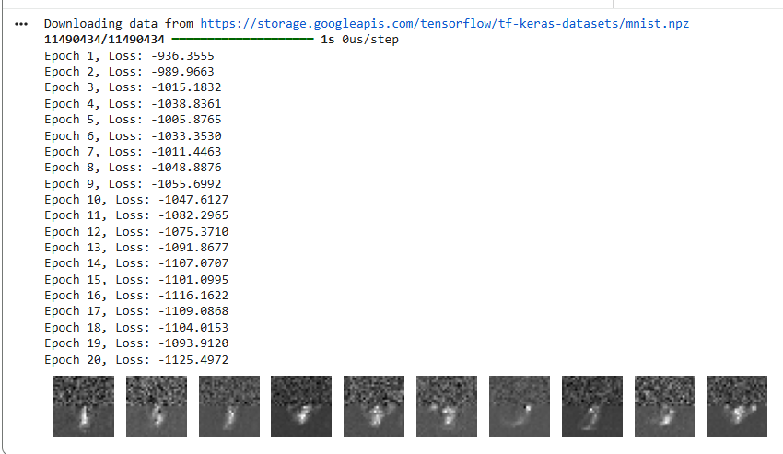

Post Lab Subjective/Objective type Questions:
- What is a flow-based generative model, and how does it differ from other generative models like GANs and VAEs?
- Why is invertibility an important property in flow-based models?
- Explain the role of the Jacobian determinant in flow-based models.
- What is the change of variables formula, and how is it applied in this experiment?
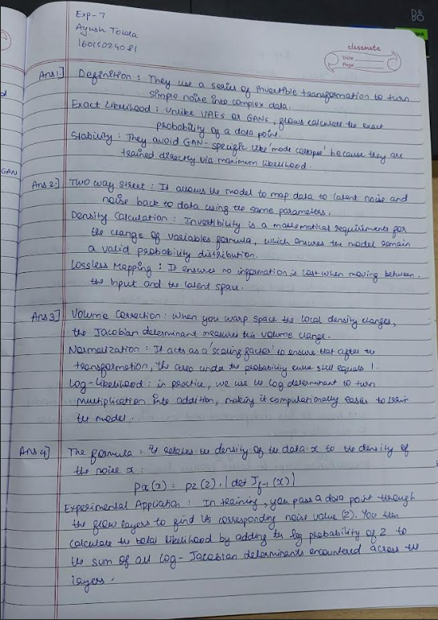

Conclusion:
Flow-based generative models provide an efficient way to learn data distributions using invertible transformations. They allow exact likelihood computation and easy generation of new samples, making them useful for tasks like density estimation and data synthesis.

Signature of faculty in-charge with Date:

